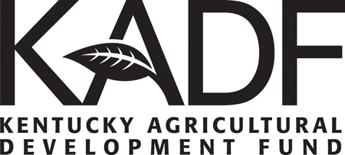
2021 County Agricultural Investment Program (CAIP)

Certification for Educational Requirement

THIS DOCUMENT IS REQUIRED FOR REIMBURSEMENT
Participation in CAIP requires a minimum of one (1) educational component attained within the last 6-months related to farm management, production, best management practices, or marketing. Eligible sessions include extension-sanctioned workshops, seminars, field days, on-line courses, webinars, etc.
- Documentation of attendance is required and the session must not have been submitted to meet CAIP education requirement for a prior year.
- A county extension agent must approve all educational sessions, by signing this individual producer “Certification for Educational Requirement.”
- Cost-share payments shall not be issued to producers before the educational requirement has been met, and this completed form has been submitted.
Your Name:

Topic:

Name of Presenter(s):

Organization sponsored session:

How does this session relate to your farm?

Write about your experience: What did you learn? What did you see? Who did you meet? What did you discover? Did you find a new business contact?

Your Signature: Date

Presenter / Event Representative’s Signature: ______________________
Title____________________ Date _________
County Extension Agent Signature of Approval: _______________________
Title____________________ Date _________

