
MONEY FOR FARM
IMPROVEMENTS AVAILABLE…
COUNTY AGRICULTURAL
INVESTMENT PROGRAM (CAIP)

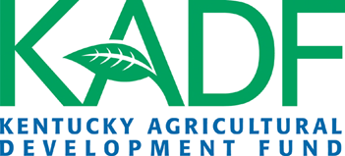
Applications are available for xxxx County’s CAIP to assist farmers in making important
farm investments.
Application Period:
Date1 through Date2, 2022

No applications will be accepted before
Date1 or after Date2

Application Availability:
Organization
Monday – Thursday (7:30 a.m. – 4:00 p.m.)

For More Information:
Contact xxxxx xxxxxx at (xxx) xxx-xxxx or email xxxxxxxxx@xxxxxxx.xxx

All applications are scored, based on the scoring criteria
set by the Kentucky Agricultural Development Board.
Administered by
Organization
address
city, KY zip
(xxx) xxx-xxxx
xxxxxxxxxx@xxxxxxx.xxx
Eligible Investment Areas:
Agricultural Diversification
AgTech & Leadership Development
Large Animal - Small Animal
Farm Infrastructure
Fencing & On-Farm Water
Forage & Grain Improvement
Innovative Ag. Systems
On-Farm Energy
Poultry & Other Fowl
Value Added & Marketing

